

**ASSIGNMENT FRONT SHEET**

**Course Name: ALY6050 20906 Intro to Enterprise Analytics**

**Professor Name:**  **Dr. Christopher Johnson**

**Student Name: Dong Quoc Tuong (Lukas)**

**Student Class: Fall 2019 CPS Term: B. 2020**

|  |
| --- |
| **Module 4: Risk and Uncertainty**  **Completion Date: March 15th Due Time:12:00am** |

**Statement of Authorship**

*I confirm that this work is my own. Additionally, I confirm that no part of this coursework, except where clearly quoted and referenced, has been copied from material belonging to any other person e.g. from a book, handout, another student. I am aware that it is a breach of Northeastern University’s regulations to copy the work of another without clear acknowledgement and that attempting to do so renders me liable to disciplinary procedures. To this effect, I have uploaded my work onto Turnitin and have ensured that I have made any relevant corrections to my work prior to submission.*

**Tick here** to confirm that your paper version is identical to the version submitted through Turnitin

**Executive Summary**

Running a business is bound to have tremendous amount of risks and uncertainty. The more risks companies are exposed to, the less likely investors will invest in the company stock. Thus, companies are looking to employ technologies in risk analysis. Researchers will often analyze the nature of various risks and which system is best for reducing it. This paper presents some of the risk common risk analysis methods and the introduction of Monte Carlo model. Then we will see how the model performs on the dataset and have a glimpse of its application in the Transportation industry.

**Background and Literature**.

There is a wide range of methods in the field of risk analysis. Firstly, the researchers will analyze qualitative nature of the object such as describing the system, identifying hazards and specifying the causes. Then they will choose the method of application out of all three based on the interest of the party:

1. **Preliminary hazard analysis or detailed hazard analysis**: Some risks, causes and effect are sufficiently detected during the preliminary analysis compared to the others that needs further analysis broken down to the lowest possible level. Therefore, they only need a simple detailed analysis of different components service life length and fault probabilities
2. **Qualitative or quantitative analysis**. Qualitative gears towards identifying the risk sources inside the companies or institutions. Quantitative, on the other hand, allows us to estimate the numerical values of the risks or probabilities for the events of interest. One such example is the employees accident rates .
3. **Inductive or deductive analysis** Inductive methods like statistical analysis can be executed if we have enough data. But if we do not have access to them, deductive serves as the alternative to generate commencement material. Most of the time, researchers use both simultaneously. (Mosquera, Reneses, Barquin, & Sanchez-Ubeda, 2006)

Monte Carlo Simulation method (MCS) is one of the most powerful risk forecasting methods at up this time. MCS’s strength lies in its ability to not only involve variety of inputs and parameter but also handle complicated systems. Furthermore, MCS can create complete probability distribution of the risks and plot realistic outcomes. All of this is executed by performing a series of testing on the system in the form of stimulations. Constant values are transformed into sets of multiple inputs and they are treated as random variables. Sampling methods will then assign values of each parameter. In the end, we will calculate the reliability indices. The whole cycle is repeated multiple times to create probability density functions of the reliability indices. In short, MCS covers all the possible outcomes, even those considered to be too unlikely. In that way, business executives can decide what to do in extreme events thanks to the variety of results instead of a single numerical one (Goerdin, Smit, & Mehairjan, 2015)

**Analysis**

We are tasked with building a Decision Model for J & G bank as well as using the Crystal Ball tools to analyze the probability of the credit cards. Firstly, we entered all the data foundational data into the table



Then after that we divide the number of approved application into full balance payers and non full balance payers. We assign the average Finance Charge factor as 3.5% (average of 3% and 4% then find the number of customers incurring charges. After taking into consideration additional charges like monthly maintenance costs and other fees, each full balance payer will pay approximately over two thousand a year for the bank. But we cannot forget that the bank also receives increase their revenue through the Non Full Balance customers. The total earning of bank at the end of the day will be the sum amount earned from full and non-full balance payers.



To calculate the total expense, we combine the total application cost to bank and losses due to change offs. Subtracting the total expense fro, the total earning of the bank we will have the net profit of $36,369,089. In other words, credit card product yields a profit of $36,369,089 annually



Using the Crystal Ball tools, we were able to create the Tornado and Spider charts below. From the Tornado Chart, The uniform distribution uncertain parameters have no effect on the revenue of the bank. On the other hand, Number of Credit cards, Customers charge and Approved Percentage are the three most important factors in determining the final revenue of the bank.In the most optimistic circumstance, the profit could be around $42,500,000 if we can issue 35126 cards, charge customer $2320 and approve 68% applications. The Spider chart resonates the same sentiment. 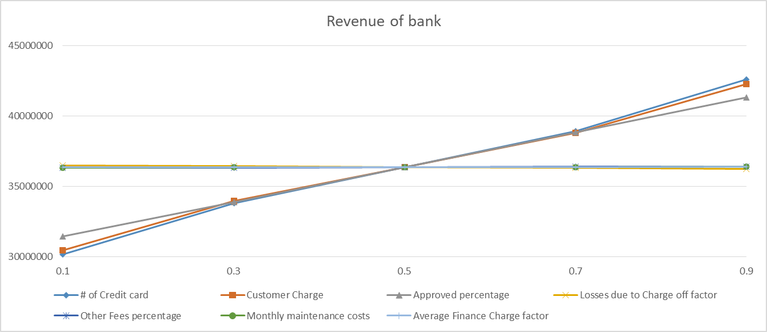

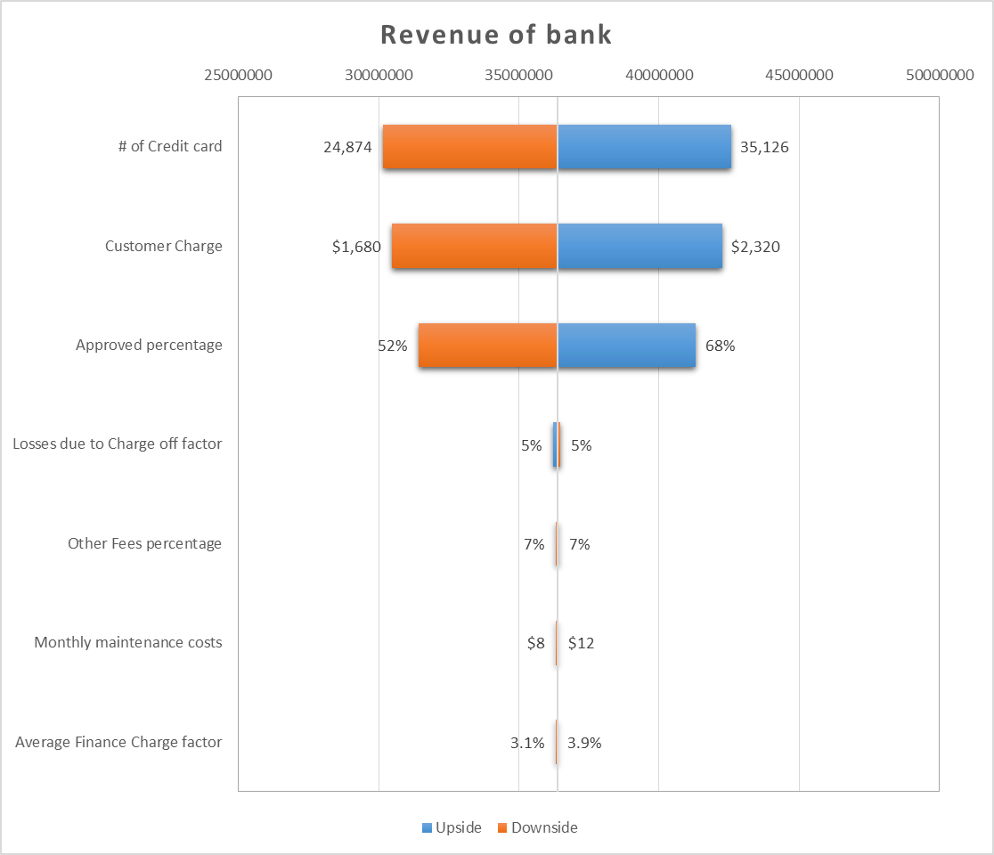

We also run the model through 10000 trials, we obtain the probability distribution below. The Sensitivity chart also illustrated that Other fees percentage, customer charge and No of credit card application and Average finance charge factor have mediocre impact on the final result. Therefore, we can say that these parameters can be assigned as fixed values





In the frequency map, if we put in the value of $36,369,089 in the box below, we would have the probability of 46.63%



**Application**

In week 4, we are dealing with Risk and Decision support analysis. I will use the “Assessment of Transport Projects: Risk Analysis and Decision Support” article to discuss the application of this method in the Transportation industry. The article presented some of the analysis (cost-benefit, quantitative risk, feasibility risk assessment) and CBA-DK model. Then they have different cases of application on the Transportation system. The most unique application of the Risk Analysis and Decision Support system is the “Motorway extension in the northern part of Sjælland, Denmark” that adheres to the Cost Benefit Analysis and Risk Analysis. The study was carried out as an ex-post analysis where the enlargement has been approved by the decision-makers. Therefore, the researchers only investigated one alternative in order to prove the risk analysis module of CBA-DK. Particularly the ontological uncertainty and the epistemic uncertainty. Bearing in mind that the feasibility risk assessment demonstrated the accepting a risk aversion around 80% would yield a greater rate of return. After running a few tests on the application and validation of the various input probability distributions, we have the summary table 4 in the paper below

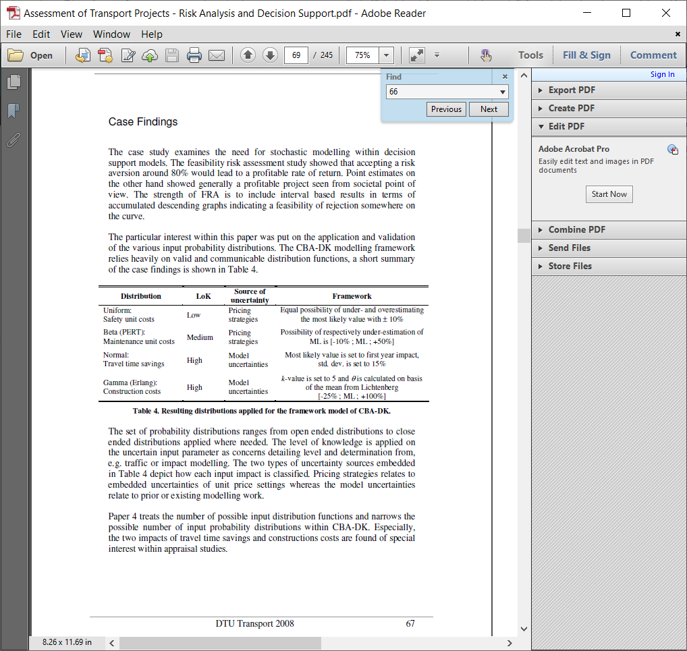

From Table 4 we can see that the two types of uncertainty sources embedded in Table 4 illustrates how each input impact is categorized. Pricing strategies correlate to the embedded uncertainties of unit price settings while the model uncertainties rely on the prior available modeling work.

**References**

Goerdin, S. A. V., Smit, J. J., & Mehairjan, R. P. Y. (2015). Monte Carlo simulation applied to support risk-based decision making in electricity distribution networks. *2015 IEEE Eindhoven PowerTech*. <https://doi.org/10.1109/ptc.2015.7232494>

Mosquera, N., Reneses, J., Barquin, J., & Sanchez-Ubeda, E. F. (2006). Risk Analysis in Electricity Markets by using Decision Trees. *2006 International Conference on Probabilistic Methods Applied to Power Systems*. https://doi.org/10.1109/pmaps.2006.360343

Salling, K. B. (2008). *Assessment of Transport Projects: Risk Analysis and Decision Support*. Retrieved from <https://orbit.dtu.dk/files/4980374/Assessment%20of%20Transport%20Projects%20-%20Risk%20Analysis%20and%20Decision%20Support.pdf>